Registration Carrier/Funder

* User arrives to landing page

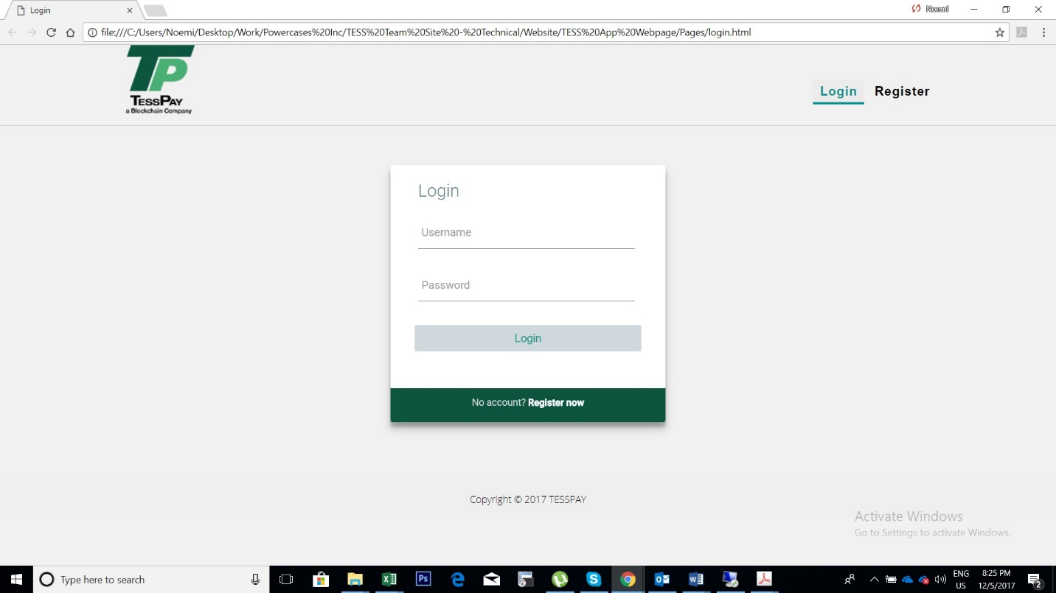

* Selects to register
* On the registration page selects the account type (Carrier or Funder), fills the details and press register

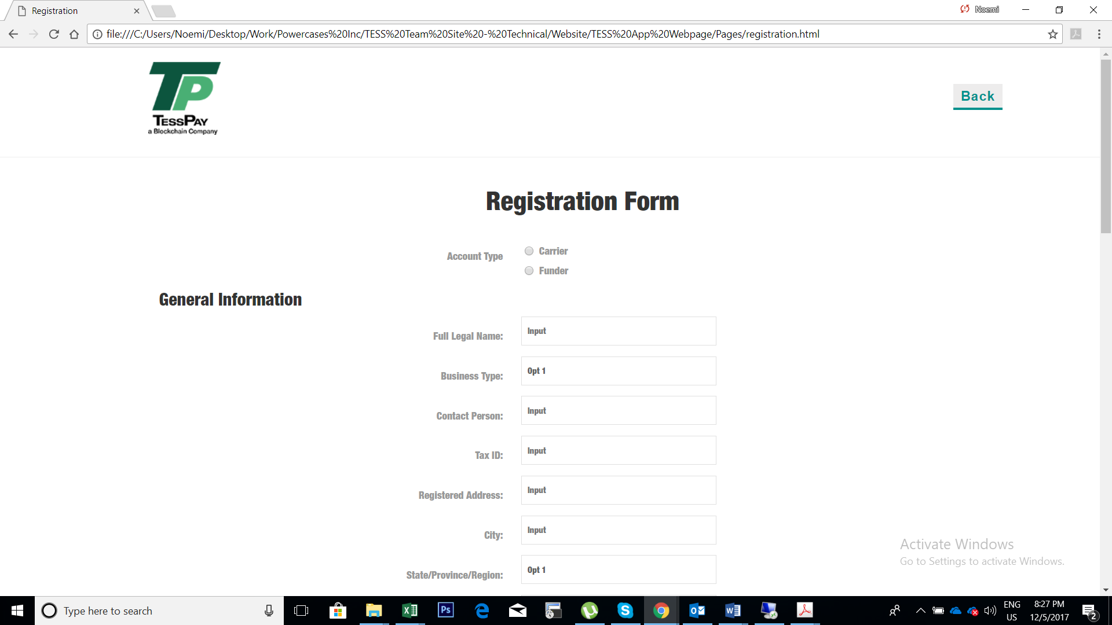

* To complete the registration the user will need to confirm the email address by entering a code received by e-mail to the email address provided on the registration page

Login Carrier Funder

* User enters the registered Username and password
* The system will automatically detect the user type and drives it to the right account (carrier, funder, Tess admin)

Authorization and Authentication

* Tess Admin Account with two menu options (for now two this will be competed in sprint 4)
* The two menu options: Authorization Roles and Access Control List
* Authorization Roles will allow the Tess Employee to select the user type from o drop down menu:

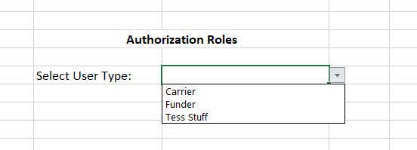

* After selecting the User Type from drop down a list with all registered user with the specified type will be displayed:

Example:

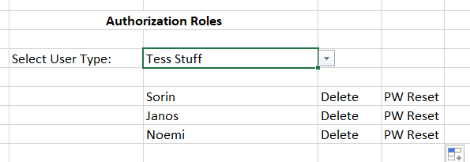

* Access Control List will contain a list with all the reports and available options in the application not taking in consideration the user type. From here Tess employee will be able to assign the report/option/filed we would like each user type to see.

Example:

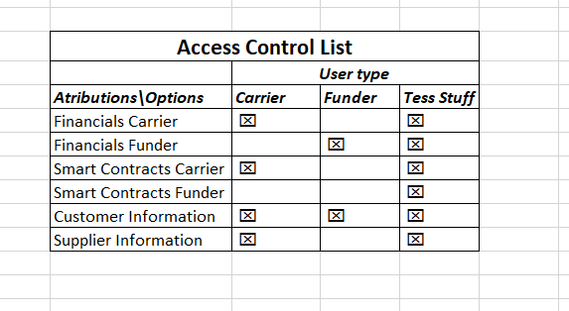

Carrier Management Page

* After Log In Carrier will have the following Menu Options and a small dashboard with most important information.

Example:

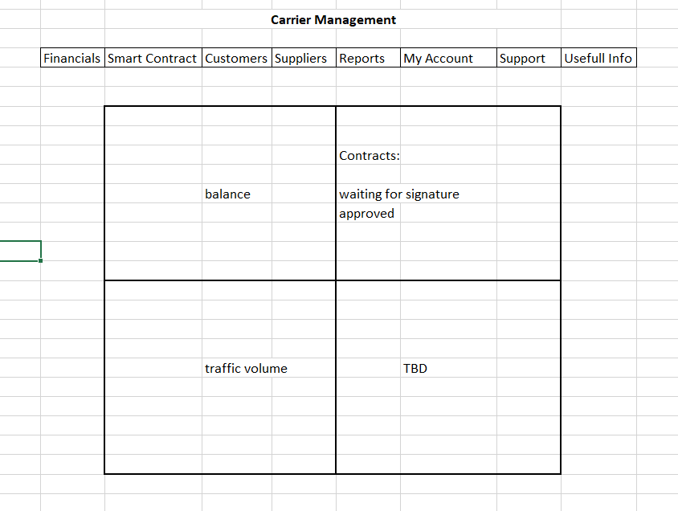

Funder Management Page

* After Log In Funder will have the following Menu Options a small dashboard with most important information.

Example:

